Indications For Use
To remove fluid and debris from a surgical site.

Description
ViSiMax™ Surgical Suction is a sterile, single use device. The device utilizes suction to remove fluid and debris during a surgical procedure.
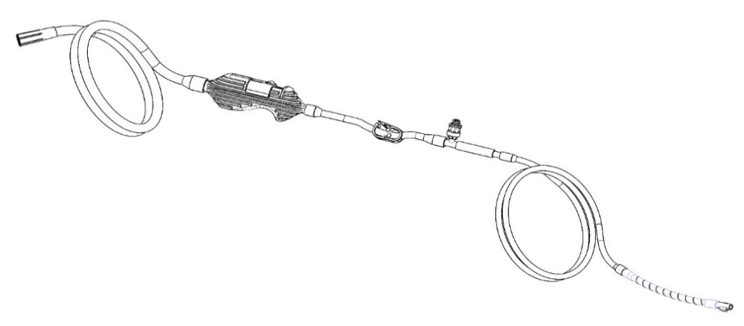
Suction Tubing
Connects to suction
source
Flush Adapter
Luer connector to flush distal tube
Control Valve
User can switch between HIGH and LOW suction
Distal Suction Tubing
Flexible tubing manipulated in the operative field
Pinch Clamp
Allows user to stop suction at the distal tip
Distal Tip
Graspable rigid tip that delivers suction to operative field

Warnings and Precautions
- These instructions are designed to assist with using this product. It is not a reference for surgical techniques.
- This device should be connected to a regulated suction source. A negative pressure setting that is appropriate for the clinical use should be selected.
- The luer fitting is provided solely for saline flushing. Do not use this port for injection, aspiration, sampling, or any purpose other than flushing. Connection to unintended devices may result in misconnections, patient harm, or device failure.
- The device is DEHP free, not made with natural rubber latex, and is sterilized using gamma sterilization.
- Dispose of all used or damaged products using standard hospital practices for biohazard control.
- This device was designed, tested and manufactured for single use only.
- DO NOT reuse, reprocess or resterilize this device.

Use of ViSiMax™ Surgical Suction
Step 1 | Step 2 | Step 3 | Step 4
Feed the device into the operative field, leading with the distal tip. | Connect the proximal suction connector into the vacuum source. Set the source to high suction (500mmHg).  During the procedure, to switch between high and low suction, slide the pressure valve in the direction on the label. | To flush the distal line, clamp the pinch clamp to turn off suction. Twist a syringe with flush media onto the needleless injection site and flush.  When finished, disengage the pinch clamp to continue applying suction to the distal tip. | Prior to removing the device from the cavity, ensure the device is not in contact with surrounding tissue and the distal tip is not engaged with any surgical instruments.  Remove by pulling the distal tubing out of the operative field.

Symbols
 | This device is intended for use by or on the order of a physician.
 | ViSiMax™ Surgical Suction is provided sterile by irradiation.
 | Do not use if the package is expired as sterility may be compromised.
 | Single patient use. Do not reuse, reprocess or autoclave the ViSiMax™ Surgical Suction as this action may compromise the safety, function, and integrity of the device.
 | Do not use if the package is open or damaged.
 | The ViSiMax™ Surgical Suction is not made with natural rubber latex.
 | Indicates the medical device manufacturer.
 | Indicates the manufacturer’s catalogue number so the medical device can be identified.
 | Indicates the manufacturer’s batch code so the batch or lot can be identified.
Model 5030

© 2025 Boehringer Laboratories, LLC
300 Thoms Drive, Phoenixville, PA 19460
1-800-642-4945 www.boehringerlabs.com Made in USA

